MEET YOUR
VICE PRESIDENT
& TREASURER
Kayla Cofield
Human Services

MEET YOUR VOLUNTEER COORDINATOR
Latesha Holloman

BS Human Services

Qualified Mental Health Professional-Trainee
Certified Mental Health Aid
Clinical Mental Health Counseling Graduate Student
Membership Director of ODU Counselor for Social Justice

MEET YOUR PRESIDENT & MEDIA MANAGER
Dawn Timms
B.A. in Business Administration
Triple Major in Leadership, Communications, and Health & Human Services. Minor in Substance abuse
Certificate in Addiction & Prevention

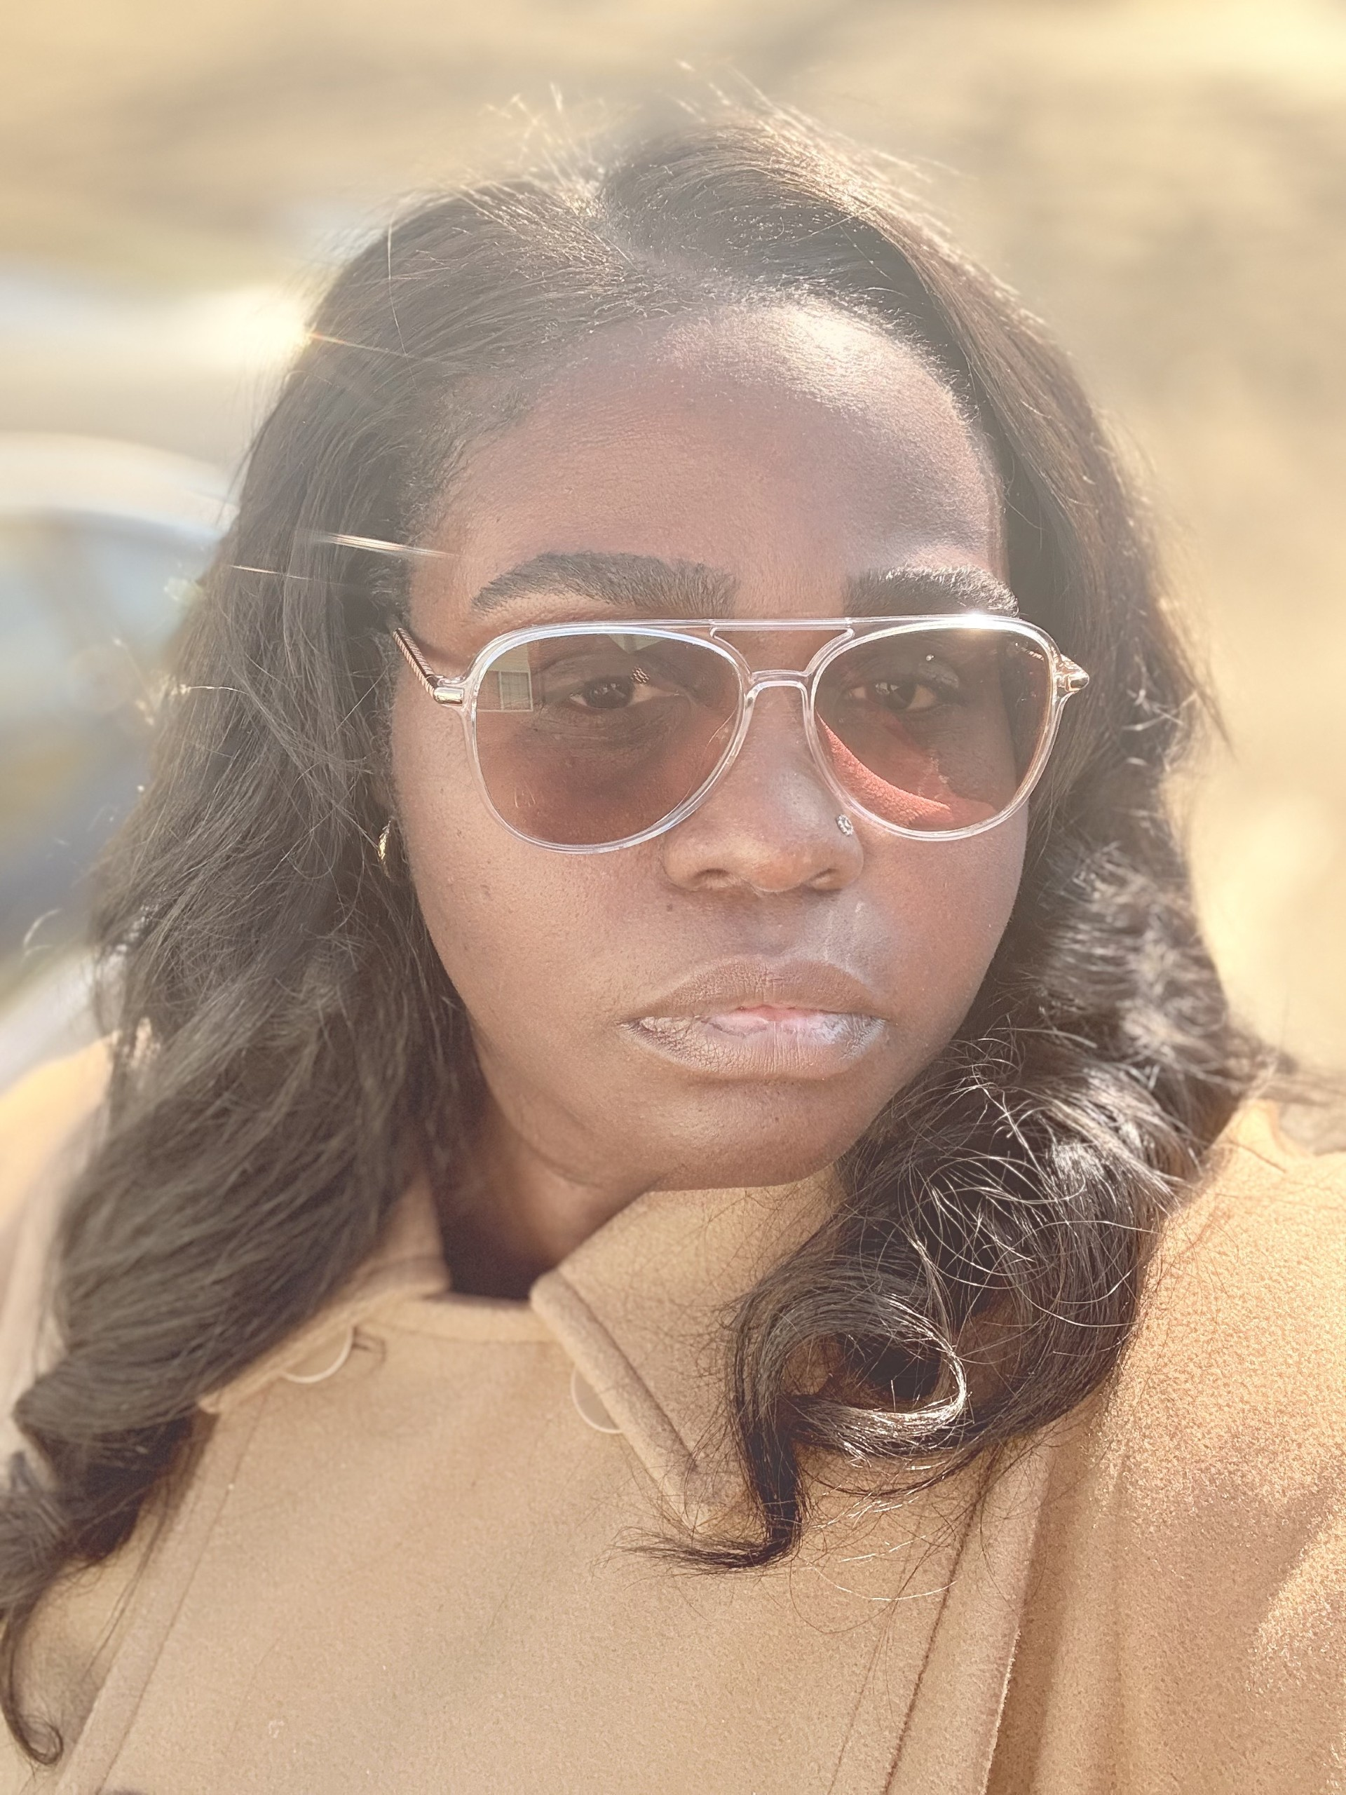
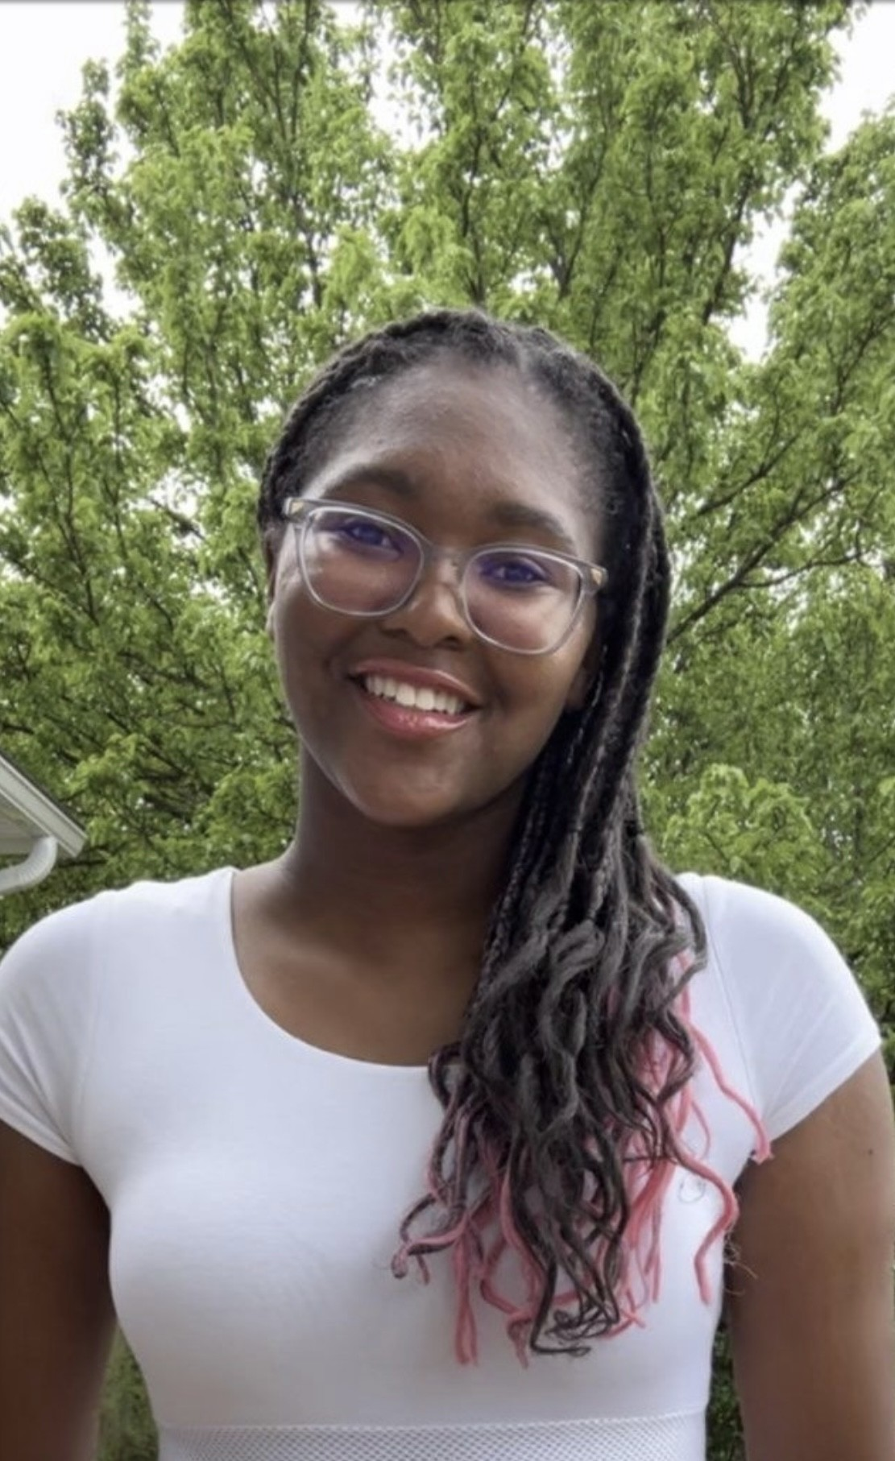
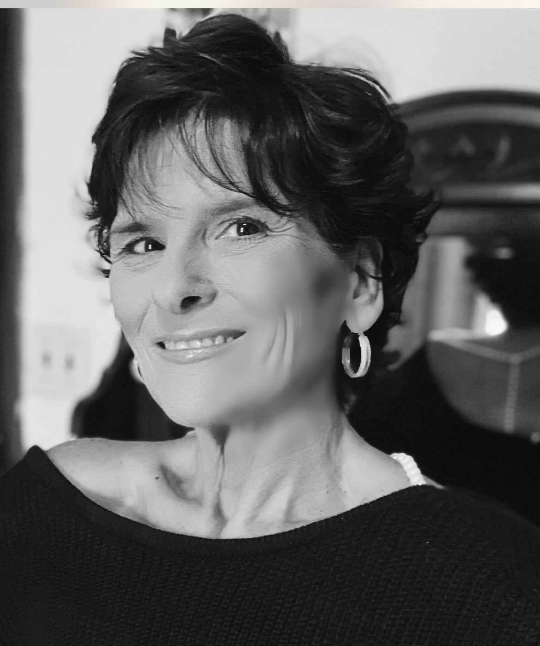
JOIN THE HUMAN SERVICES ASSOCIATION
OLD DOMIONION UNIVERSITY | 2025 – 2026 ACADEMIC YEAR
- Are you passionate about making a difference in your community?
- Interested in leadership, service, and real-world experience in human services?
- Are you interested in collaborating with other students on service projects?
- Do you want to develop leadership skills and expand your professional network?

We’re a student led organization dedicated to:
- Building inclusive, compassionate communities
- Connecting academic learning to hands-on service
- Raising awareness around mental health, elder care, domestic violence, and more
- Creating transparent systems for outreach, fundraising, and volunteer coordination

