Instructions on how to submit a Budget Request on Campus Groups
- From the main Campus Groups home page (https://odu.campusgroups.com/groups), please ensure that you’re an active office of the organization. At the top left hand corner of the page, select the “Groups” Icon above the Orange arrow and search for your organization.
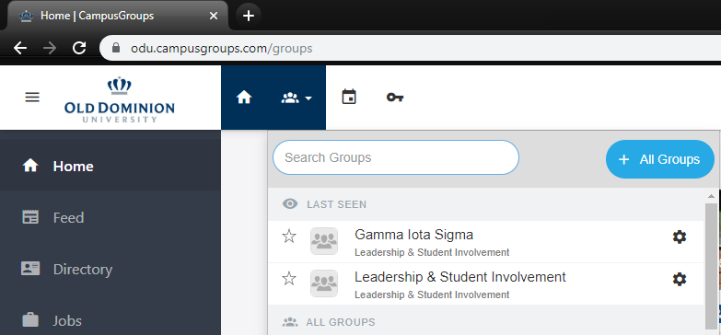
- You should now be on the organization’s main Dashboard. From the dashboard, on the left-hand pane, select “Money” “Budgeting”. You will be taken to your budget portal.
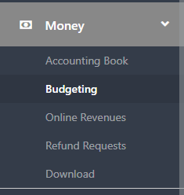
- Be mindful that there are 3 different types of budget funding sources when requesting budgets: SGA Budget, Co-sponsorship and Contingency. Be sure to select the appropriate source when submitting a budget request. This can be selected toward the top right-hand side of the portal.
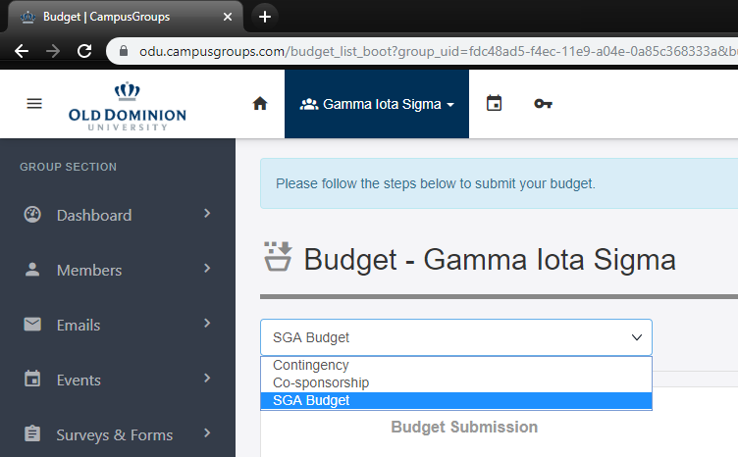

- At the top right-hand side of the page, select the “Create Budget Request” Icon
- Here, you’ll be able to create and edit budget requests for your organization. This is step 1 of the budget submission process. On the next page is a sample of what your treasurer might enter.
  - Budget Request Type: Your budget requests will fall into one of the request types: Programming, Travel and Office Supplies.
  - Title: Enter the title of what you are requesting.
  - Description: Provide a detailed explanation of what you’re requesting and why you’re requesting it.
  - Priority: indicating level of priority of this budget request.
  - Documents: this is where you’d upload any and all price quotes from vendors. These are important as these are used when determining the amount of money your organization can receive per request.

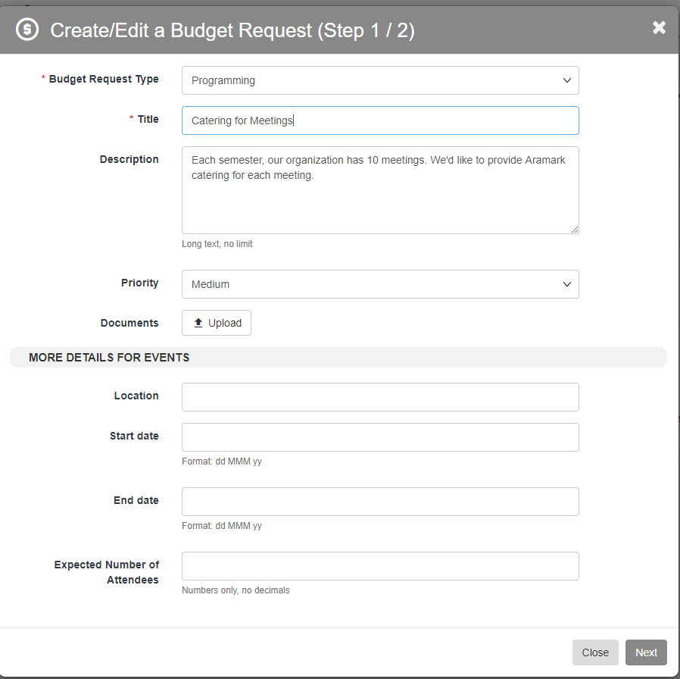
- Click “Next”. This brings you to the “Enter Budget Items” section, or step 2 of the submission. Here, you can add as many or as few line items as you’d like by clicking “+ Add Item”. See the sample request below. Enter the amount you’re requesting per item type under the “Amount Requested” column. Feel free to enter notes as well.
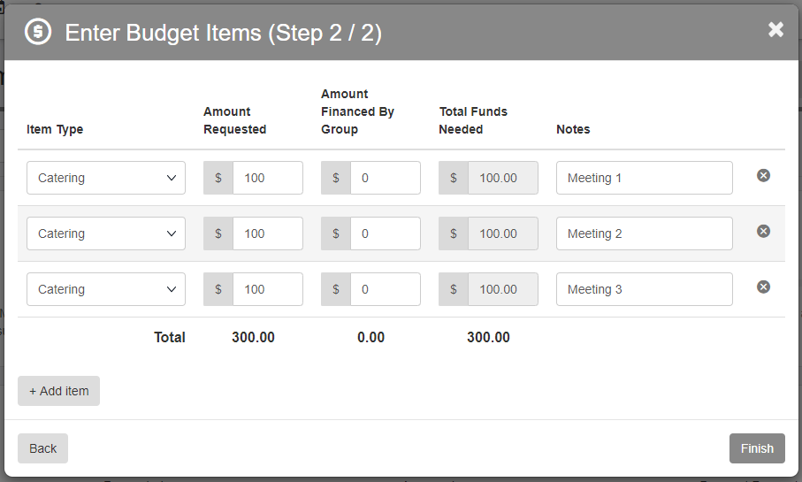
- Once you’ve completed your budget request, select “Finish” at the bottom right-hand side of the request.
- Once all budget requests are entered, select “Submit Budget” under Budget Submission.

