Instructions on how to submit a Payment Request on Campus Groups
Note: This can ONLY be done once your organization has received budget approval. Please refer to the instructions on how to submit a budget request before continuing.
- From the main Campus Groups home page (https://odu.campusgroups.com/groups), please ensure that you’re an active officer of the organization. At the top left hand corner of the page, select the “Groups” Icon located above the orange arrow and search for your organization.

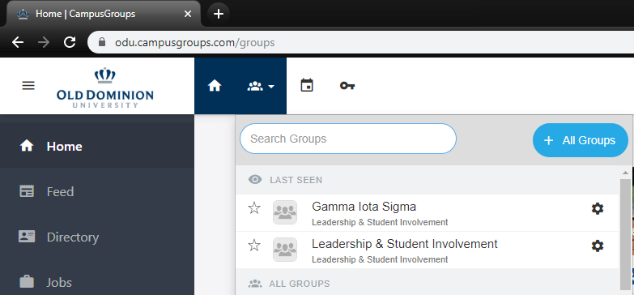

- You should now be on the organization’s main Dashboard. From the dashboard, on the left-hand pane, select “Money” “Budgeting”. You will be taken to your budget portal.
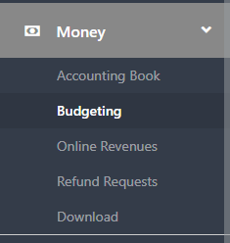
- Be mindful that there are 3 different types of budget funding sources when requesting payments: SGA Budget, Co-sponsorship and Contingency. Be sure to select the appropriate source when submitting a budget request. This can be selected toward the top right-hand side of the portal. The following page will load:
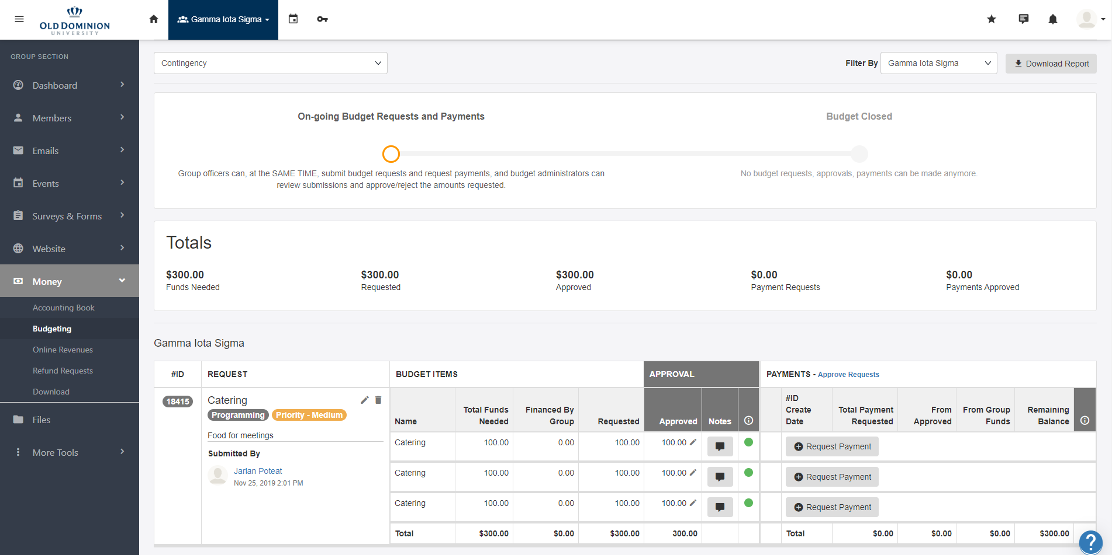
- If the organization has received budget approval, there will be a “Request Payment” next to each line item that has been approved within your budget. Select the corresponding “Request Payment”.
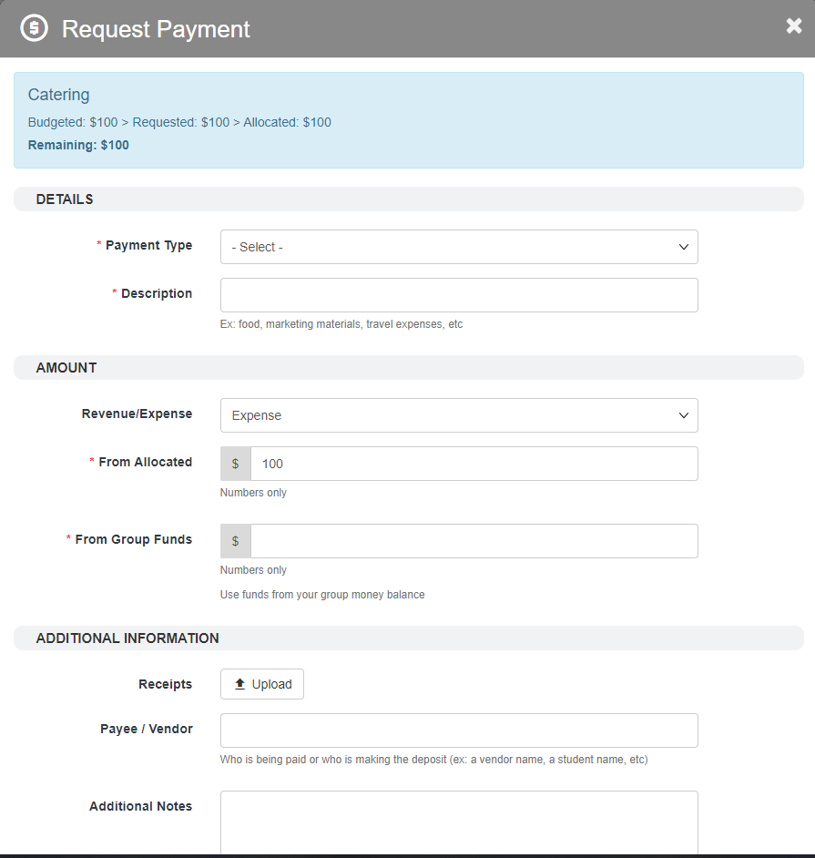
- You’ll be taken to the Request Payment form. Here, you will fill out the details needed to properly make a payment request.
  - Payment Type: Please select: LSI Finance.
  - Description: provide a brief description of what you will be purchasing.
  - Revenue/Expense:
  - From Allocated: This field prepopulates with how much is left in this line item. Enter the amount requested here.
  - From Group Funds: These are remaining group funds from your group money balance.
  - Receipts: This is where you will upload receipts, price quotes, any supporting documentation needed to finalize your payment request.
  - Payee/Vendor: Indicate the vendor/payee the request is intended for.
  - Additional Notes: anything else you might feel the need to add.
- Select “Next” at the bottom right hand corner of the payment request. You will be taken to the “Payment Request Form”
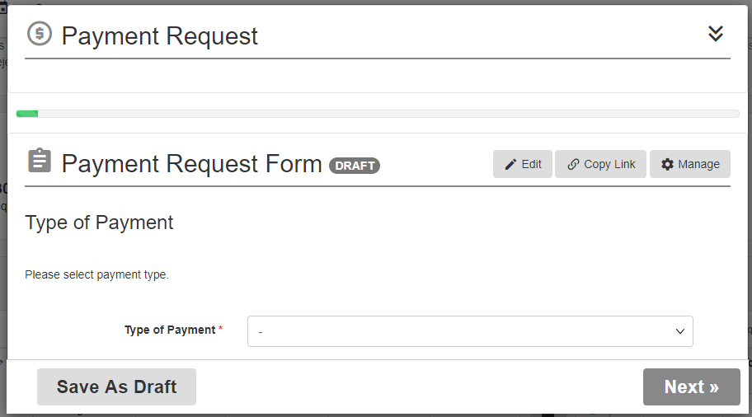
- Here, you will select the Type of Payment request. Each option will prompt a different form unique to your respective selection; (i.e., selecting the “Catering” option will bring up the catering form. The different payment types are:
Bookstore Requisition, Catering, Contract, Conference Registration, Hotel Prepayment, Online Purchase, Poster Printing, Reimbursement, and Transportation.

- Upon completion of the respective Payment Type form, click the “Submit” at the bottom right hand corner of the payment request.

